AI BASED PERSONAL FINANCE MANAGER
Conclusion, Future Scope and References
Department of Computer Science and Engineering, TKR College of Engineering & Technology
Batch C11 (CSE-C) · Academic year [ACADEMIC YEAR]
Table 1: Project team
S.No. | Student name | Roll number
1 | Mekala Kalyan | 23K91A05F0
2 | Rajanala Sai Hemanth | 23K91A05K3
3 | Middala Surya Teja Reddy | 23K91A05F2
4 | Manga Akash | 23K91A05E5

Project guide: N Padmavathi
Chapter and section numbers quoted in the text (for example Chapter 8 or Section 6.2) refer to the full project report, 17.Final Document. Figures and tables in this document are numbered from 1.

1. CONCLUSION

1.1 Summary
FINJARVIS is a working AI-based personal finance manager. A person signs up, records or imports transactions, and sees a dashboard with income, expenses, savings, net worth, a categorised spending breakdown, a next-month forecast, budget alerts and a 0-100 financial health score. An assistant answers questions from the person's own records, and reports can be downloaded as PDF, Excel or CSV. It is built from a React front end, a FastAPI back end with 33 routes, a service layer shared with the original Streamlit application and a SQLite database.
The work was verified by 38 pytest tests and a 49-check smoke test, and its machine-learning parts were measured on a probe set, a backtest, simulation and random profiles. The honest result is mixed: the platform and the explainable modules work, the categoriser and the forecast are simple and break in the ways reported, and the base paper's anomaly detector, budget recommender and deep models were not built.

1.2 Objectives against outcomes
Table 2: Objectives against outcomes
Objective | Outcome | Evidence
1 Secure accounts with transaction import and manual entry | Achieved | bcrypt, signed tokens, per-user scoping; manual entry and CSV/Excel import (916 of 1,000 rows imported, 84 bad rows skipped); 49 of 49 smoke checks
2 Categorise expenses automatically from descriptions | Partly achieved | 71.7 percent on the probe set but 18.2 percent on unseen merchants; 51 seed examples; 11 categories
3 Forecast expenses and savings with time-series models | Partly achieved | Linear trend on monthly expenses only; no ARIMA or LSTM; MAPE 28.4 percent on the backtest, not better than a mean
4 Detect anomalous transactions | Not achieved | No anomaly detector exists; only the largest expense in a window is shown
5 Personalised budget recommendations and threshold alerts | Partly achieved | Alerts at 75, 90 and 100 percent and rule-based advice from the user's data; budgets are set by the user, no learned recommender
6 Interactive dashboard of spending, categories and forecasts | Achieved | 13 pages in dark and light themes; dashboard 67 ms and analytics 72 ms median

1.3 Key findings
1. The categoriser is accurate where its vocabulary overlaps the seed list (100 percent on seed-like text, 97 percent on statement strings) and weak elsewhere (18.2 percent on unseen merchants), against 51.5 percent for the keyword table over the whole probe set.
2. Its mistakes are not random: 48 of 56 errors are labelled Transport (precision 0.273), because the model has no way to say it does not know.
3. A confidence threshold of 0.15 would keep 62.1 percent of the probe items at 94.3 percent accuracy, so abstaining is a practical improvement the app does not yet make.
4. One correction fixes a repeat merchant (18.2 to 100 percent) but forty-eight corrections move unseen-merchant accuracy only to 21.5 percent.
5. The linear-trend forecast is not better than a plain average for short histories: MAPE 28.4 against 21.4 percent on the demo backtest, and in simulation it overtakes the mean of all months at 7 months of history and the mean of the last three months only at 9 months, so the three-month minimum is too low.
6. The health score behaves sensibly (no decrease when the savings rate rises in 5,000 random profiles) but saturates: the savings-rate component stops changing at 20 percent, and its weights are not fitted.
7. The rule-based assistant is correct when it answers and silent about much of what users might ask: 14 of 20 answerable questions handled, 6 of 6 off-topic questions declined.
8. The application is fast for one user: every dashboard, list and analytics endpoint answers in under 82 ms median, reports in 136 to 209 ms, with login (305 ms) the slowest by design.
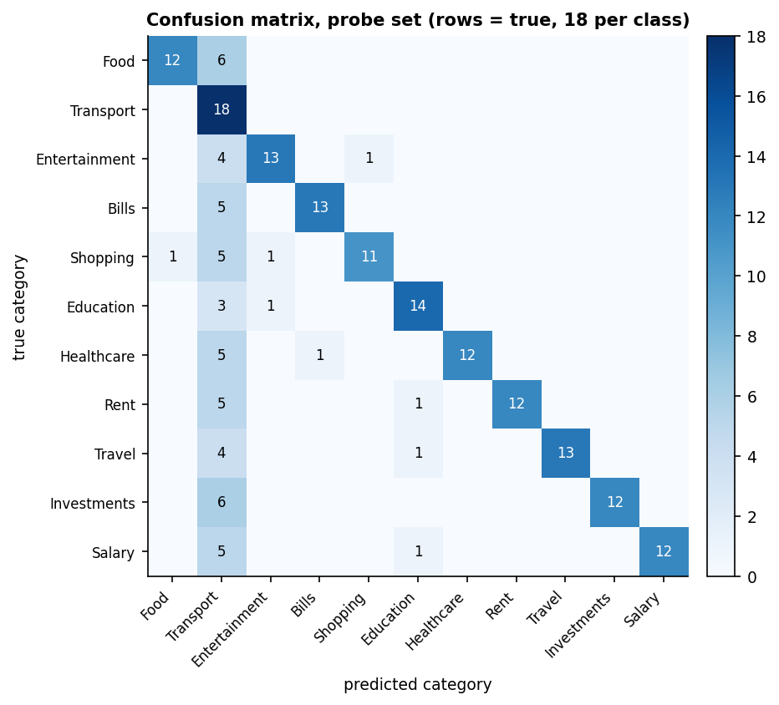
Figure 1: Confusion matrix of the shipped categoriser on the probe set: the Transport column collects the unseen-merchant errors.
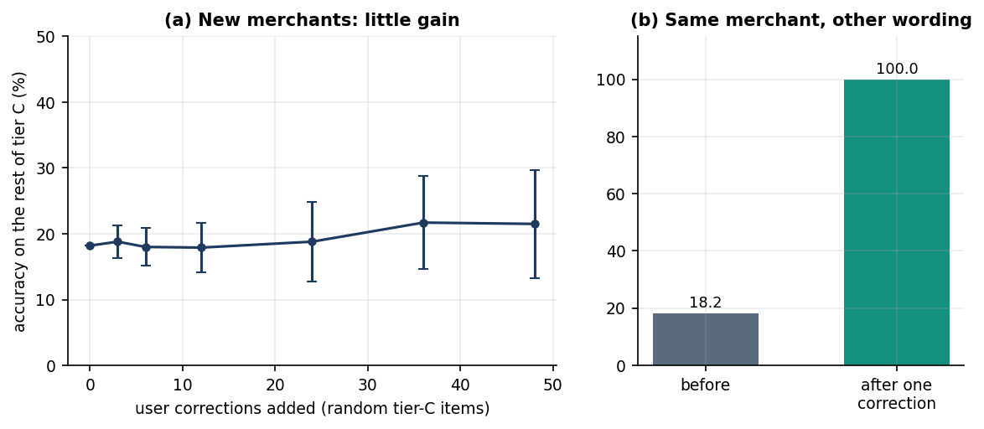
Figure 2: Learning from corrections: new merchants gain little, a repeat merchant is fixed by one correction.
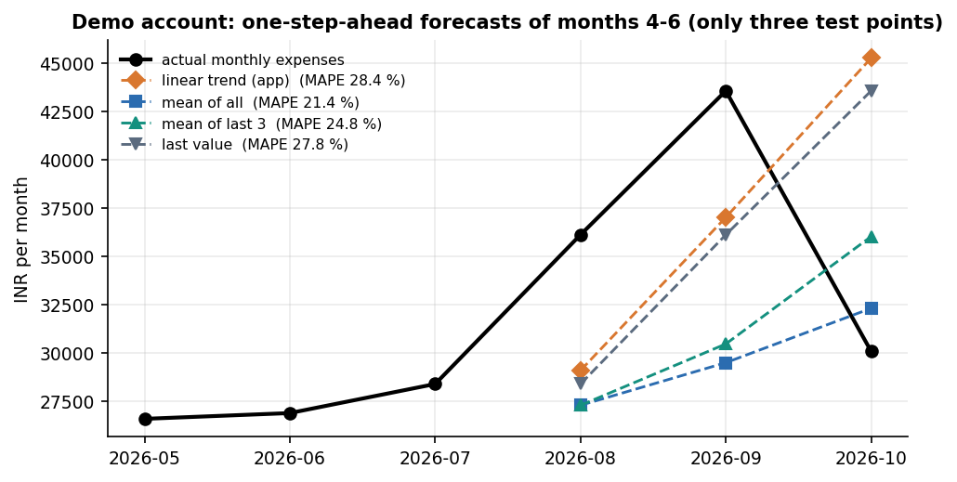
Figure 3: Forecasts for months 4-6 of the demo account with four methods; the actual spend fell in the last month.

1.4 Limitations
The evidence is a team-written probe set, fictional demo data and seeded simulation rather than field data, there was no user study, and the defects listed in the limitations section remain open. The results demonstrate a working, inspectable platform, not that its models are accurate on real transactions.
The measurements behind the key findings are shown below: how the categoriser behaves on the three probe tiers, how the forecast methods compare on the demo account, and how forecast error depends on the length of history in simulation. The probe set was written by the team and the simulation is seeded; neither is field data, and neither is a replication of the base paper's experiments.
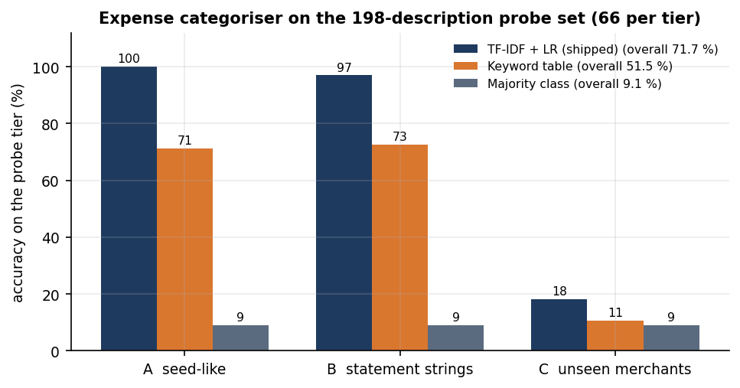
Figure 4: Accuracy of the shipped categoriser, the keyword table and the majority class on the three probe tiers.
Figure 5: Demo account: forecasts of months 4-6 with four methods (three test points).
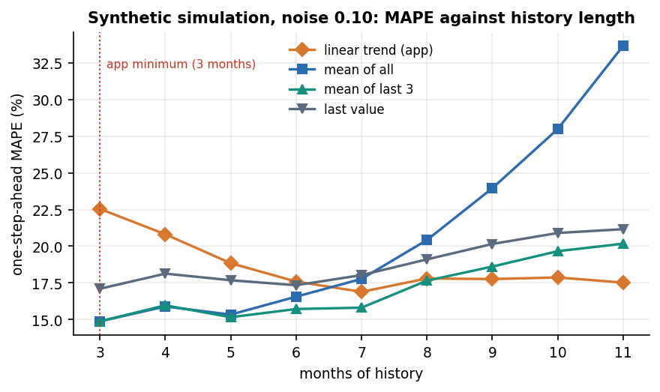
Figure 6: Synthetic simulation: forecast error against months of history (noise 0.10).

2. FUTURE SCOPE

2.1 Close the defects found
• Let the categoriser abstain. Return Other or ask the user when the top probability is below 0.15, which on the probe set keeps about 62 percent of items at about 94 percent accuracy; show the confidence next to the label.
• Fall back to a mean for short histories. Use the mean of the last three months until about seven months exist, and raise the minimum above three months.
• Fix alert de-duplication and month ends so that a budget crossing the same threshold in a later month raises a new alert, and compute month ends with the calendar.
• Replace the token scheme with a standard library, require APP_SECRET_KEY and refuse to start with the default, and add a login rate limit.
• Batch the import commit into one transaction so that a 1,000-row file takes seconds instead of tens of seconds.

2.2 Complete the objectives that were missed
• Anomaly detection. Start with a robust z-score per category, then an Isolation Forest on amount, category and day features, and measure precision and recall on injected outliers as the base paper does.
• Savings forecasting. Forecast income minus expenses, and compare a seasonal mean, exponential smoothing and ARIMA with the current line using a rolling-origin backtest.
• A learned budget recommender. Begin with a rule that proposes budgets from the last three months, and consider reinforcement learning only if real histories justify it.

2.3 Add features
• A loan and debt tracker with amortisation schedules and prepayment comparison, as named in the abstract.
• A scheduler for weekly or monthly digests and recurring-transaction detection.
• Bank and SMS import through statement parsers or an account-aggregator API, and merchant-name normalisation.
• A larger labelled corpus from consenting users and public sets, then a comparison of the current model with a linear model on character n-grams and a small transformer.
• Testing the language-model layer with a key, including answer faithfulness against the database.

2.4 Deploy and scale
• Move to PostgreSQL with Alembic migrations, run several workers behind a reverse proxy and keep secrets in the environment.
• Add load tests, automated browser tests and a dependency audit to the test suite, and monitor latency and error rates.

3. REFERENCES
[1] R. Kharat, S. Solapurkar, A. Tikkas, M. Uttarwar and A. Yadav, "A smart AI-based personal finance assistant: A multi-model approach for expense categorization, budgeting, forecasting and anomaly detection," Int. J. Research in Applied Science and Engineering Technology (IJRASET), vol. 13, no. XI, pp. 167-180, Nov. 2025, doi: 10.22214/ijraset.2025.75019.
[2] P. L. To, "Enhancing financial literacy and management through goal-directed design and gamification in personal finance application," arXiv:2601.08640, Jan. 2026.
[3] A. Theerthala, "Synthesizing behaviorally-grounded reasoning chains: A data-generation framework for personal finance LLMs," arXiv:2509.14180 [cs.CL], Sep. 2025.
[4] V. Dilip and R. S. Janaki, "FinSenseAI: An explainable AI-based personal finance recommendation and expense prediction system using hybrid machine learning models," Int. J. Innovative Science and Research Technology, vol. 11, no. 7, pp. 1637-1650, Jul. 2026, doi: 10.38124/ijisrt/26jul842.
[5] F. R. Abiya, S. Parvathy, M. R. Devende, S. R. Ajmalsha and C. Viji, "Personal expense leakage detection and budget optimization using machine learning," Int. J. Research in Applied Science and Engineering Technology (IJRASET), Apr. 2026, doi: 10.22214/ijraset.2026.79467.
[6] "AI-driven financial insights for personal budget planning: A smart approach to future expense prediction," in Proc. 2025 3rd Int. Conf. on Intelligent Data Communication Technologies and Internet of Things (IDCIoT), IEEE, 2025 (IEEE Xplore document 10914721; as listed in the batch survey, authors not verified).
[7] "AI-driven finance management platform for intelligent expense tracking and budget automation," Int. Research J. of Modernization in Engineering Technology and Science, 2026 (as listed in the batch survey; not located, not verified).
[8] J. Devlin, M.-W. Chang, K. Lee and K. Toutanova, "BERT: Pre-training of deep bidirectional transformers for language understanding," in Proc. NAACL-HLT, 2019, pp. 4171-4186.
[9] D. Araci, "FinBERT: Financial sentiment analysis with pre-trained language models," arXiv:1908.10063, 2019.
[10] F. T. Liu, K. M. Ting and Z.-H. Zhou, "Isolation forest," in Proc. 8th IEEE Int. Conf. on Data Mining (ICDM), 2008, pp. 413-422.
[11] S. Hochreiter and J. Schmidhuber, "Long short-term memory," Neural Computation, vol. 9, no. 8, pp. 1735-1780, 1997.
[12] C. J. C. H. Watkins and P. Dayan, "Q-learning," Machine Learning, vol. 8, no. 3-4, pp. 279-292, 1992.
[13] N. V. Chawla, K. W. Bowyer, L. O. Hall and W. P. Kegelmeyer, "SMOTE: Synthetic minority over-sampling technique," J. Artificial Intelligence Research, vol. 16, pp. 321-357, 2002.
[14] F. Pedregosa et al., "Scikit-learn: Machine learning in Python," J. Machine Learning Research, vol. 12, pp. 2825-2830, 2011.
[15] G. Salton and C. Buckley, "Term-weighting approaches in automatic text retrieval," Information Processing & Management, vol. 24, no. 5, pp. 513-523, 1988.
[16] R. J. Hyndman and A. B. Koehler, "Another look at measures of forecast accuracy," Int. J. Forecasting, vol. 22, no. 4, pp. 679-688, 2006.
[17] S. Makridakis, E. Spiliotis and V. Assimakopoulos, "Statistical and machine learning forecasting methods: Concerns and ways forward," PLoS ONE, vol. 13, no. 3, e0194889, 2018.
[18] R. J. Hyndman and G. Athanasopoulos, Forecasting: Principles and Practice, 3rd ed. Melbourne, Australia: OTexts, 2021.
[19] A. Lusardi and O. S. Mitchell, "The economic importance of financial literacy: Theory and evidence," J. Economic Literature, vol. 52, no. 1, pp. 5-44, 2014.
[20] N. Provos and D. Mazieres, "A future-adaptable password scheme," in Proc. USENIX Annual Technical Conf., FREENIX Track, 1999, pp. 81-91.
[21] R. T. Fielding, "Architectural styles and the design of network-based software architectures," Ph.D. dissertation, Univ. of California, Irvine, 2000.
[22] M. Bayer, "SQLAlchemy," in The Architecture of Open Source Applications, Volume II, A. Brown and G. Wilson, Eds. 2012.
[23] R. Kohavi, "A study of cross-validation and bootstrap for accuracy estimation and model selection," in Proc. 14th Int. Joint Conf. on Artificial Intelligence (IJCAI), 1995, pp. 1137-1143.

